***Traditional Architecture:***

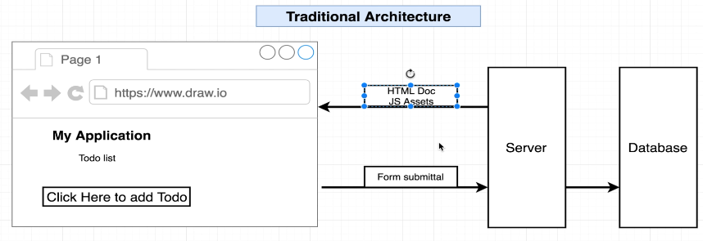

***Ethereum Architecture:***

***Ethereum Architecture:***